Methods of scientific research
1. General logical methods of scientific research
2. Methods of empirical research
3. Methods of theoretical research
Method (from the Greek methodos - literally translated "the way to something") is used in the broadest sense as a way to achieve a goal, an orderly activity in a certain way. In science, the method is understood as a means of obtaining knowledge. The methods of scientific cognition are studied in detail in the logic and methodology of scientific cognition.
One of the main characteristics of the scientific method is its proportionality (relevance) to the subject and object of scientific knowledge.
○ The word "relevant" (from the English relevant – essential, relevant, having significance for something) is usually used in conjunction with other words, forming concepts of different meaning and content: relevant logic, linguistic relevance, relevant method, etc.
The relevance of the method means, first of all, its proportionality, consistency, correlation with all components of the cognitive process: the object and subject of research, the subject and the specifics of the scientific discipline, with the goals and type of scientific knowledge.
In the philosophical literature, it is customary to divide methods into general logical, empirical and theoretical research methods.
General logical methods are used in both theoretical and empirical research.
Induction is a method of research and a way of reasoning in which a general conclusion is based on particular premises.
The scheme of inductive reasoning is as follows:
there is S1, which has the property p
there is S2, which has the property p
there is an Sn having the property p
------------------------------------------------------------
therefore, all S is p
* Distinguish between full and incomplete induction.
* A complete induction is a conclusion in which a general conclusion about a certain class is made on the basis of studying all subjects of this class, and in an incomplete one - on the basis of studying only a part of this class.
* In science, as a rule, incomplete induction is used.
* The concept of "deduction" is used in a broad and narrow sense.
* Deduction in the narrow sense is a method of reasoning by which private reasoning necessarily follows from general premises.
* In the broad sense of the word, deduction refers to all logical means of argumentation and proof without recourse to empirical methods.
* In scientific knowledge, justification and proof are essential characteristics.
* Proof is a set of logical techniques to substantiate the truth of a thesis. The structure of the proof includes: thesis, arguments and demonstration.
* A thesis is a judgment whose truth must be proved.
* Arguments are true judgments that are used to prove a thesis. The following types of arguments are distinguished: facts, definitions, axioms, previously proven laws or theorems.
* A demonstration or a form of proof is a method of logical connection between a thesis and arguments.
There are direct and indirect proofs. Direct proof goes from consideration of arguments to proof
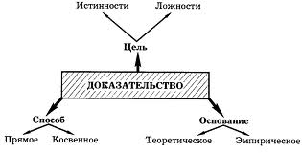
Analysis (Greek analysis - decomposition) is the mental or actual dismemberment of an integral object into its component parts (elements, sides, signs, properties, relationships, etc.) in order to study them. Decomposition of the whole into its component parts allows to reveal the structure of the object under study, its structure; to separate the essential from the non-essential; to reduce the complex to the simple. One of the forms of analysis is classification. The purpose of the analysis is the cognition of parts as elements of a complex whole.
Анализ The analysis can be substantive (physical) and mental. In the first case, there is a real dismemberment, the division of the object into its component parts, and in the second, this dismemberment occurs only in consciousness.
Synthesis (Greek synthesis - connection) is the connection of previously isolated parts of an object into a single whole. As already noted, analysis and synthesis are two interrelated methods. "Only by connecting mentally (or experimentally), the researcher realizes the parts as parts of a given whole; only by decomposing mentally (or experimentally), the researcher realizes the whole as consisting of specific parts and consequently having a specific property that distinguishes it from other objects"[1].
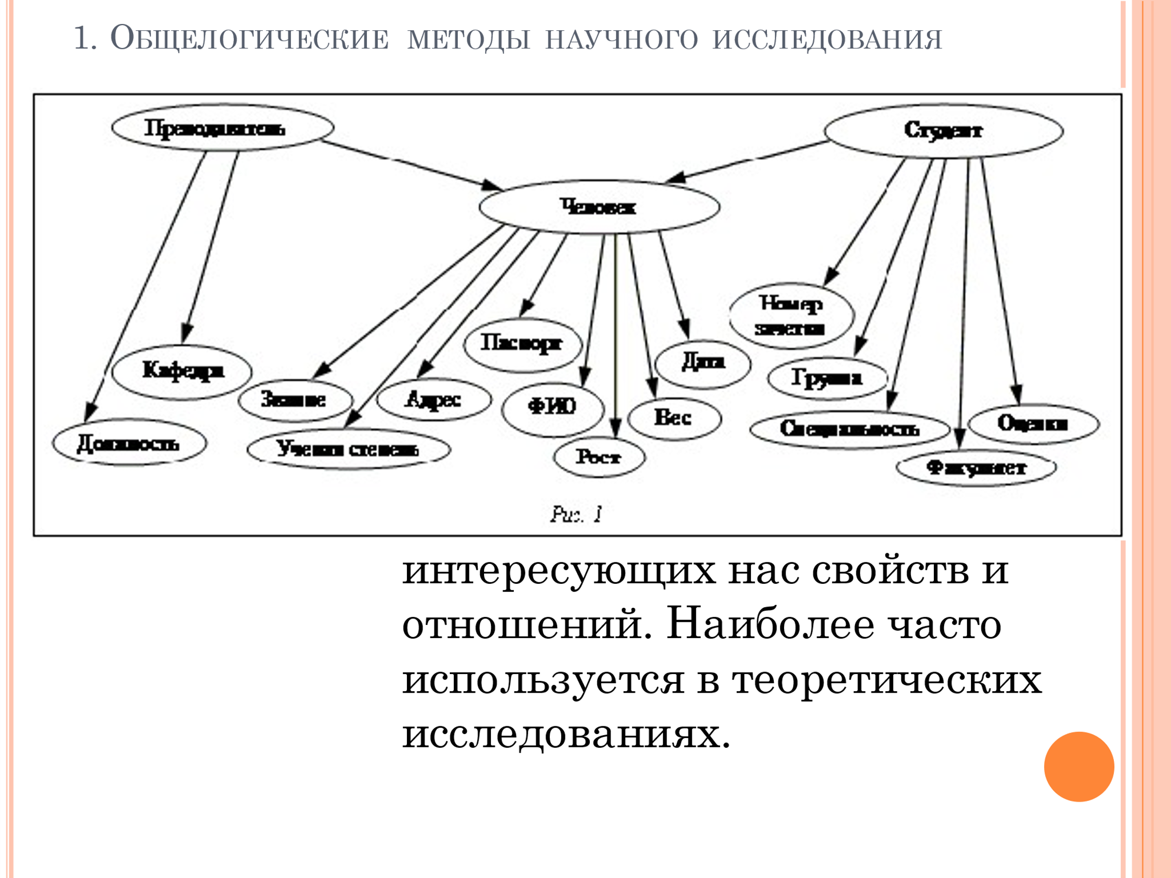

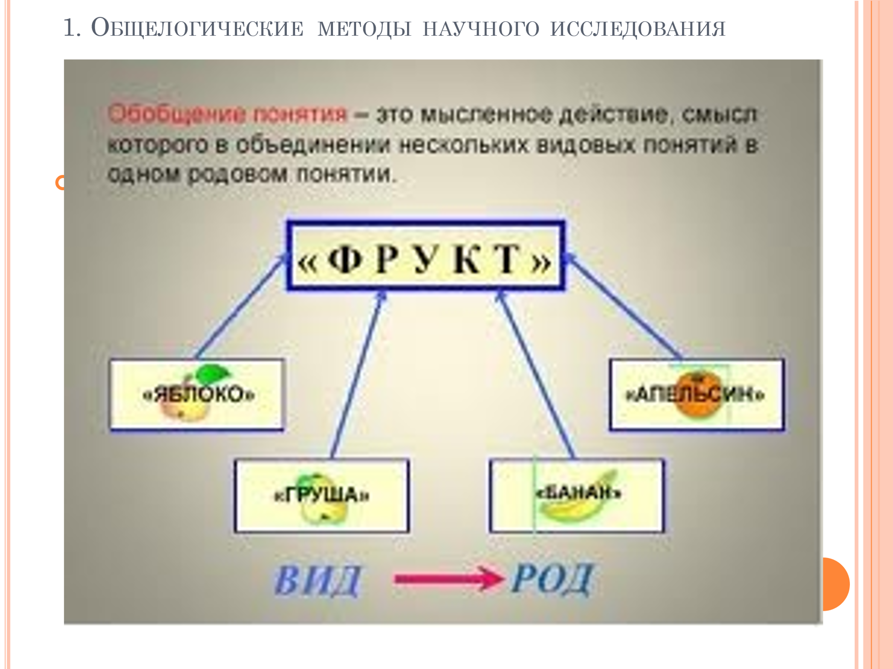
Analogy (Greek analogy - correspondence) is a method of cognition and thinking in which, based on the similarity of objects in some features, they conclude about their similarity in other features. The scheme of inference by analogy:
object B has the signs a, b, c, d, e;
object C has the attributes b, c, d, e;
○ In order to increase the probability of inference by analogy, the following requirements are imposed on it:
○ 1) the analogy should be based on essential features and, if possible, on a greater number of similar properties of the objects being compared;
2) the relationship of the attribute about which the conclusion is made with the common features found in objects should be as close as possible;
3) the analogy should not lead to the conclusion about the similarity of objects in all signs;
4) the conclusion by analogy should be supplemented by studies based on other methods.
Modeling is the study of an object (original) by creating and researching its copy (model), replacing the original from certain sides of interest to cognition. Models can be both real and ideal (mathematical). The achievements of modern science and technology have largely become possible thanks to the construction and research of mathematical models of real objects using computers. When modeling (whether physical or mathematical), it is not the real object that is being investigated, but its model.
Observation is a purposeful and organized perception of the phenomena of reality, during which we gain knowledge about the external sides, properties and relationships of the object
Observation can be simple and complex, direct and indirect, i.e. adjacent to the experiment.
○ With direct observation, the selected object itself is observed. In indirect (indirect) observation, the properties of the observed object are judged by its interaction with other objects.
Простое Simple observation is observation without the use of special means. Complex - observation with the use of special means (microscope, telescope, etc.).
○ Unlike an experiment, there is no predominant influence of the subject on the object in observation.
Methods of empirical research
○ In the act of observation , they distinguish:
1) object of observation;
2) subject;
3) funds;
4) observation conditions;
5) a knowledge system based on which the purpose of observation is set and its results are interpreted.
The main requirement for scientific observation is intersubjectivity, i.e. the ability to obtain the same results by different observers. Observation is a necessary element of other empirical methods and is therefore considered a kind of scientific practice.
In the philosophy of science, the concept of "description" functions in two meanings: broad and narrow. In a broad sense, the concept of description also includes theoretical forms of knowledge that describe the patterns of functioning of the objects under study.
○ In a broad sense , we can talk about the following forms of scientific description:
1. Parametric - description of the properties, attributes and relationships of the object under study.
2. Morphological - is associated with the identification of the structure of the object under study.
3. Functional - description of functional dependencies between parameters (functional-parametric description), between structural elements of the object (functional-morphological description) or between parameters and the structure of the object.
4. Behavioral - a description aimed at presenting a holistic picture of the object under study and ways of its functioning.
In a narrow sense, description is the fixation of observation or experiment data by means of natural or artificial language. Since the subject of our analysis is the methods of empirical research, we will understand the description in the narrow sense of the word.
The main function of the description is to prepare the transition to the theoretical study of the object, i.e. to the explanation. Description is inextricably linked with explanation. On the one hand, an explanation is impossible without a description, on the other, a description in many ways becomes possible only due to the existence of previous theoretical knowledge about the reality under study.
Description is divided into two types: qualitative and quantitative. One of the varieties of quantitative description is measurement.
Measurement is the process of representing the properties of real objects in the form of numerical quantities.
Experiment (Latin experimentum - trial, experience) - the study of any phenomena by actively influencing them by creating new conditions corresponding to the goals of the study, or by changing the flow of the process in the right direction.
Экспери Experiments conducted to establish patterns or discover facts are called search experiments. Experiments conducted to test a theory or hypothesis are called verification experiments.
○ Stages of the experiment:
An experiment is always a question addressed to nature. Initially, the question is formulated in the language of theory, i.e. in theoretical terms denoting abstract, idealized objects. In order for the experiment to answer the question of theory, this question needs to be reformulated in empirical terms, the meanings of which are empirical objects or empirical data. This is the first stage of the experiment, which can be called an empirical interpretation of theoretical questions.
The second stage is the selection of conditions and devices used. This stage is determined by the empirical interpretation of theoretical values and the elimination of side effects.
The third stage is the impact on the object, observation of its behavior and measurement of controlled quantities. The experiment can be represented as a system of measured variables. All experimental variables are divided into dependent and independent. The experimenter can determine the dependent variables directly himself, based on the goals of the experiment.
Simplistically, the experiment can be represented as finding a function: X = f (Y), where X is an independent variable and Y is a dependent one.
The fourth stage is the processing of the data obtained, as well as the reverse translation of empirical terms into theoretical ones.
The methodological arsenal of theoretical research is based on general logical research methods. However, theoretical research has its own specific methods. These methods relate, first of all, to the methods of constructing the subject of theoretical research (idealization and formalization) and to the methods of logical organization of knowledge within theory (axiomatic and hypothetical-deductive methods).
The process of creating idealized objects that are fundamentally impracticable in experience and reality is called idealization. Idealized objects are the ultimate cases of certain real objects (a material point, an ideal gas, an absolutely black body).
There are several ways to form ideal objects.
1. Abstracting from some properties of objects and retaining others. For example, a "material point" is an ideal object with only gravitational mass.
2. Abstracting from the relations between objects. For example, the concept of "ideal gas" is obtained by abstracting from the interaction between gas molecules.
3. Attributing to real objects a property that they lack or mentally bringing their inherent properties to the limit value. For example, an absolute mirror or an absolutely black body.
4. The mental placement of real objects in non-existent, ideal conditions, for example, when inertia is not taken into account.
5. A combination of methods 1-4.
Idealization helps us to single out the sides of reality that interest us in a pure form and, based on a relatively simple idealized object, give a deeper and more complete description of these sides.
Formalization is the representation of an object or phenomenon in the sign form of an artificial language (mathematics, chemistry) and providing the possibility of studying real objects and their properties through the formal study of the corresponding signs.
The peculiarity of formalization as an epistemological technique is that the identification and refinement of the content performed with its help occur through the identification and fixation of its form.
The main functions of formalization in scientific cognition are reduced to the following: clarification, analysis and definition of concepts, which contributes to increasing their unambiguity, certainty and accuracy; increasing the rigor and accuracy of proof by presenting it with a sequence of formulas; the possibility of creating algorithms of mental operations based on formalization, which are a prerequisite for creating programs for computers.
Although formalization is widespread in theoretical research, it has limits. Thus, the Austrian logician and mathematician Gödel proved the incompleteness theorem of sufficiently rich formalized theories, according to which there is always an undeclared, non-formalized remainder in the theory.
In turn, A. Tarsky proved the theorem on the non-formalizability of the concept of truth. Thus, there is a limitation of deductive and expressive possibilities of formalized theories.
The axiomatic method of constructing a theory is a method of constructing a theory by introducing axioms and deductively deducing possible consequences from them.
Правила Rules and sequence of the axiomatic method:
○ 1) a certain set of axioms accepted without proof of the propositions of a certain theory is chosen;
2) the concepts included in them are not explicitly defined within the framework of this theory;
3) the rules of definition and rules of inference of this theory are fixed, which allow introducing new terms (concepts) into the theory and logically deducing some sentences from others;
○ 4) all other propositions of this theory (theorems) are derived from axioms (1) based on certain rules (3)
○ Гипот Hypothetical-deductive method of theory construction
The essence of this method is to create a system of interconnected hypotheses. By the deductive method, empirically verifiable consequences are deduced from the initial hypotheses.
Построение The construction of a theory based on the hypothetical-deductive method includes several stages:
○ 1. Analysis of factual material, which is the initial empirical base of the studied area of reality.
2. Making guesses and assumptions about the regularities of the studied area.
3. Selection of the most plausible guesses and formulation of initial scientific hypotheses based on them.
4. Deduction by deductive method from the initial hypotheses of empirically verifiable consequences.
5. Experimental verification of the consequences.



